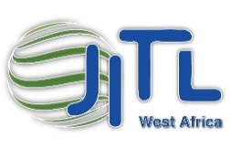

Ireland – Josefa International Trading. Ltd. Ireland.
Ivory Coast- Josefa International Trading West Africa.
Company Reg. No. 557540. Ireland. Company Reg No. N RCCM CI ABJ 2016 B 26758. Ivory Coast

C / o JITL. Ltd
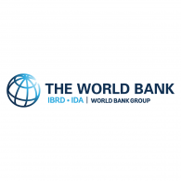
Unit H3, Centrepoint Business Park,
Oak Road, Clondalkin,
Dublin 12,
The Republic of Ireland.
0035314608090
www.jitl.ie
jitlceo@gmail.com

CEO. Dr. Daithí Ó Murchú.PhD
00353879240180
domurchu1@gmail.com

The Gross Domestic Product (GDP) in Ivory Coast was worth 58.79 billion US dollars in 2019, according to official data from the World Bank and projections from Trading Economics. The GDP value of Ivory Coast represents 0.05 percent of the world economy.
