pose message Tap for popup settings
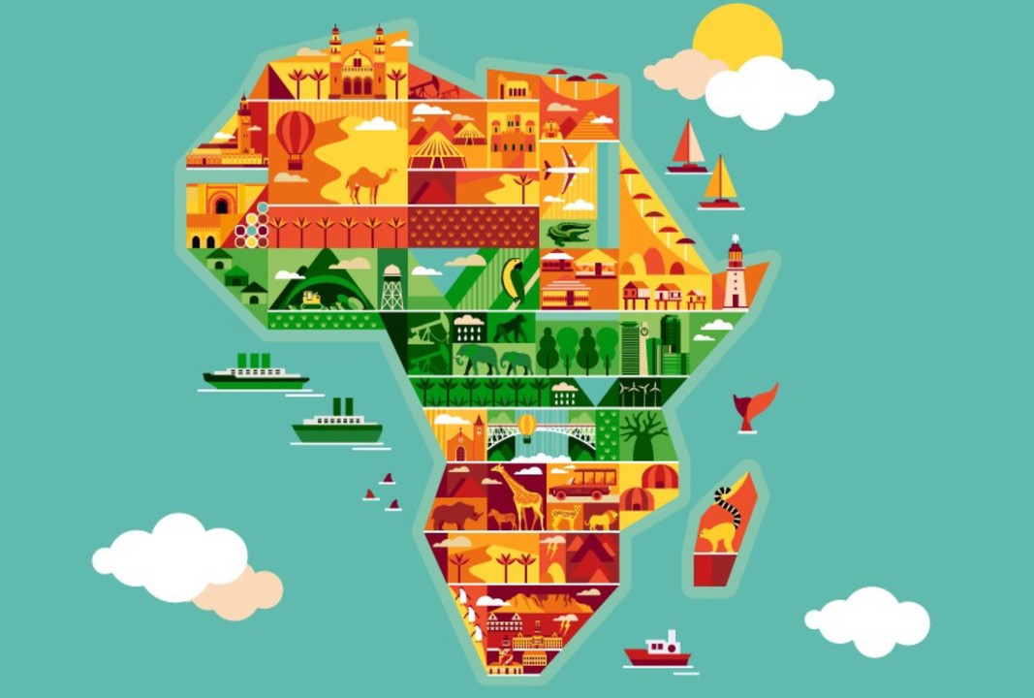

Within 12 years, Nigeria & South Africa will no longer dominate the African continent, report

- Published on May 26, 2018

Mark-Anthony Johnson

Euromonitor International said on Friday, May 25, 2018: "Africa’s two largest economies‚ Nigeria and South Africa‚ accounted for nearly 50% of the continent’s GDP in 2017. However‚ by 2030 these two countries will represent just 37% of Africa’s total GDP‚ demonstrating the rising economic importance of Africa’s emerging markets."
Ethiopia and Rwanda are expected to be the two fastest growing economies in Africa by 2030‚ the report states.
The financial institution predicted the growth prospects for all 55 nations in Africa, looking ahead to 2030. Ethiopia is set to improve its GDP by a huge 7.5%, closely trailed by Rwanda at 7.2%.
Mozambique is the only other country expected to see its economy grow by 7% or more, sitting in third place. Côte d’Ivoire and Sierra Leone make up the top five.
Furthermore‚ the report states, Africa will show the highest growth in disposable income globally over the forecast period to 2030‚ at 9% compound annual growth rate (CAGR).
Euromonitor International’s report‚ titled “Shifting Market Frontiers: Africa Rising”‚also identifies key trends‚ some of which are summarized here:
- Africa is the world’s second most populous continent. Its growing young population is expected to command nearly 20% of the world’s population by 2025. Equally so‚ rapid urbanisation and fast-growing consumer expenditure provide long-term opportunities.
- Diversity of consumers in Africa’s 55 independent states "requires a more granular and regional approach for a successful and sustained market entry".
- A flexible long-term strategy is required to succeed in the continent. "Despite signs of growing GDP and consumer expenditure‚ the challenges of the continent‚ such as lack of infrastructure‚ paucity of skills and political instability‚ require a flexible and long-term approach."
- Africans are increasingly connected. With high mobile penetration - reaching one billion in 2017 - 2030‚ Africa will also have 16% of the world’s internet users‚ which reflects growth of over 260% from 2017. "This offers opportunities in various consumer industries‚ which include finance‚ apparel‚ food and drink‚ and beauty and personal care."
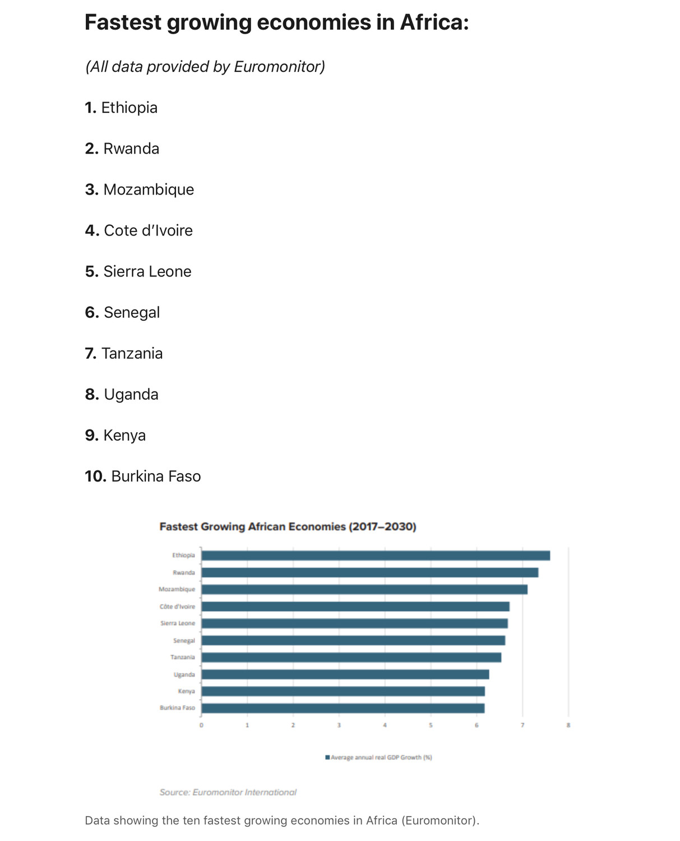

Sources: Times Live | JIC Media

